**

**Softech** **Solutions Inc.**

[www.softechnosolutionsgroup.com](http://www.softechnosolutionsgroup.com)

[saney.alam@softechnosolutionsgroup.com](mailto:saney.alam@techsolutions.tech)

# A Complete Guide for Beginners

JMeter – Introduction & Installation

***Lecture Notes***

JMeter – Introduction & Installation

# Table of Contents

|  |  |
| --- | --- |
| ***Table of Contents Page*** | |
| ***Introduction to Apache JMeter*** | ***02*** |
| ***Features Supported By JMeter*** | ***03*** |
| ***JMeter Architecture Working Process*** | ***04*** |
| ***JMeter Installation Guide*** | ***05*** |
| *Check for Java on Windows* | *05* |
| *Download and Installation Process of JMeter* | *06* |
| *Step 1: Download Process of v3.2 JMeter* | *06* |
| *Step 2: Installation Process of v3.2 JMeter* | *07* |
| *Start JMeter In Three Different Modes* | *08* |
| *The GUI Mode: JMeter runs on client computer* | *08* |
| *In Server Mode: JMeter runs on Server Computer* | *10* |
| *In Command Line Mode* | *10* |
|  |  |

# **Introduction to Apache JMeter**

Apache JMeter is a great open source application with awesome testing abilities. Web Server is a platform which carries loads of numbers of applications and users, so that it is necessary to know that how does it works or performs means; how effective it is to handle simultaneous users or applications.

For example; how the “Gmail” supporting server will perform when numbers of users simultaneous access the Gmail account – basically have to do performance testing using performance testing tools like JMeter, Loadrunner etc.

To check the high performance of the application or server, do high performance testing using JMeter for exceptional results.

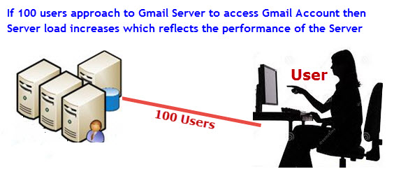

Fig: A Sample Scenario

Before understanding Overview of JMeter, let us have a look on three testing approach,

**Performance Test:** This test provides the best possible performance of the system or application under a given configuration of infrastructure. Very fast, it also highlights the change need to be made before application goes into production.

**Load Test:** This test is useful for determining and preceding the system under the top load it was aimed to work under.

**Stress Test:** This test tries to break the system by crushing its resources.

JMeter design is based on plugins. Most of its “out of the box” features are applied with plugins. Off-site developers can simply spread JMeter with custom plugins.

JMeter works on these many protocols: Web Services – SOAP / XML-RPC, Web – HTTP, HTTPS sites ‘web 1.0’ web 2.0 (ajax, flex and flex-ws-amf), Database – JDBC drivers, Directory – LDAP, Messaging Oriented service – JMS, Service – POP3, IMAP, SMTP, FTP.

# **Features Supported By JMeter**

People really think of that why they should go for JMeter? So, to clear their drought, let us get to know JMeter awesome features,

**Open source application:** JMeter is a free open source application which facilitates users or developers to use source code for other development or modification purpose.

**User – friendly GUI:** JMeter comes with natural GUI. It is very simple and easy to use and users get familiar very soon with it.

**Platform independent:** Although, it is totally a Java based desktop application. That’s why; it can run on any platform. It is highly extensible and capable to load the performance test in many different server types: Web – HTTP, HTTPS, SOAP, Database via JDBC, LDAP, JMS, Mail – POP3.

**Write your own test:** Using plugins, write your own test case to extend the testing process. JMeter uses text editor to create a test plan and supplies in XML format.

**Support various testing approach:** JMeter supports various testing approach such as Load Testing, Distributed Testing, and Functional Testing, etc.

**Simulation:** JMeter can simulate various users with simultaneous threads, generate heavy load against web application under test.

**Support multi-protocol:** JMeter works on web application testing and database server testing, and also supports protocols such as HTTP, JDBC, LDAP, SOAP, JMS, and FTP.

**Script Test:** JMeter is capable to perform automation testing using Bean Shell &Selenium.

**Totally multi-threading framework:** It’s a full multi-threading framework permits simultaneous sampling by many threads and simultaneous sampling of different functions by distinct thread groups.

**Easily understandable test result:** It visualizes the test result in a format such as chart, table, tree and log file are very simple to understand.

**Easy installation step:** Just run the“*.bat” file to use JMeter. In Linux/Unix – JMeter can be approached by clicking on JMeter shell script. In Windows – JMeter can be approached by starting the JMeter.bat file.

# **JMeter Architecture Working Process**

JMeter simulates number of users send request to an appropriate server which shows the performance/functionality of an appropriate server / application via tables, graphs etc. The figure below depicts this process:

[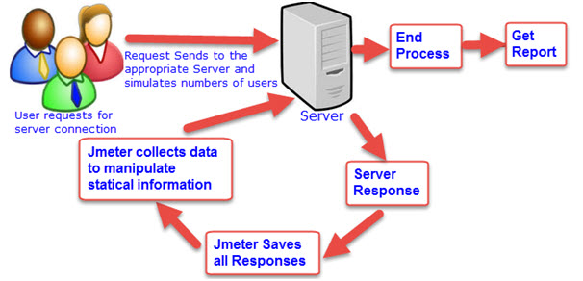](http://www.softwaretestingclass.com/wp-content/uploads/2014/02/jmeter-architecture-working-process.jpg)

Fig: JMeter Architecture

# **JMeter Installation Guide**

JMeter is a pure Java desktop application, that’s why it runs on any system which supports Java. So before installing JMeter, first get to know the basic requirement of JMeter to run on local windows machine.

|  |  |  |  |  |  |
| --- | --- | --- | --- | --- | --- |
| **Operating system** | **Window XP** | **Window 7** | **Free BSD 9.0** | **Linux 2.4, 2.6, 3.1** | **Mac OS** |
| **Java Virtual Machine** | Sun JDK6, Sun JDK 7 | Sun JDK 5, 6, 7. | Open JDK 6 | Sun JDK 5, 6, 7 and Open JDK 6 | JDK6 |
| **Architecture** | 32/64 bits | 32 bits | amd64 | i386, amd64 |  |

## Check for Java on Windows

Before installing JMeter, just check your system is supporting Java or not, if not then install it because JMeter is a pure Java desktop application. You can verify that java is already installed in your windows machine or not using bellow given command in your command prompt. You can use the following procedure to check whether Java JDK is installed successfully in your system.

In Window/Linux – Just go to Terminal or click on start and type “**command prompt**”

Open the “command prompt” and type command “**java –version**”.

If Java run-time environment is installed successfully, you will see the output as figure below,

[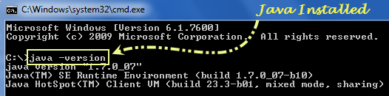](http://www.softwaretestingclass.com/wp-content/uploads/2014/02/jmeter-check-java-version.png)

If Java run-time environment is not installed successfully, you will see the output as figure below,

[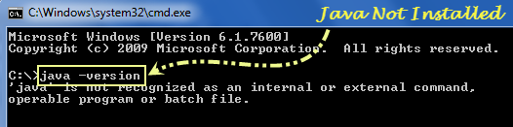](http://www.softwaretestingclass.com/wp-content/uploads/2014/02/jmeter-java-not-installed.png)

You can get the latest version of Java SE Development Kit in the site: http://www.oracle.com/technetwork/java/javase/downloads/index.html, using this site download and install the latest version of Java SE Development Kit. After installation, just check java is installed successfully or not using command “Java – Version” in the command prompt.

## Download and Installation Process of JMeter

### Step 1: Download process of v3.2 JMeter

After checking Java, just download JMeter through the site:

http://jmeter.apache.org/download_jmeter.cgi   
The latest version of JMeter is v3.2, go to the site and choose the Binaries file (either zip or tgz) to download as shown in figure below,

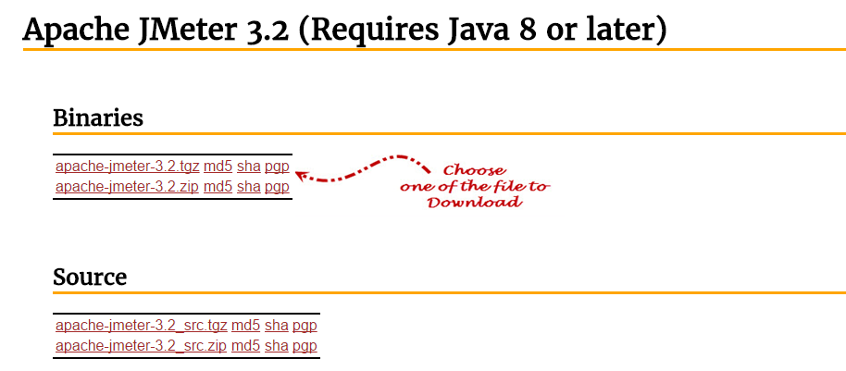

### Step 2: Installation process of v3.2 JMeter

It is very simple and easy to install JMeter, just download the “.zip” or ”.tgz” file and unzip JMeter file into the directory where you want to install JMeter. A very simple and easy installation process and it’s [how to get provigil without prescription](http://onhealthy.net/product/provigil/) done. After unzip process is done, the directory will look like the given below figure,

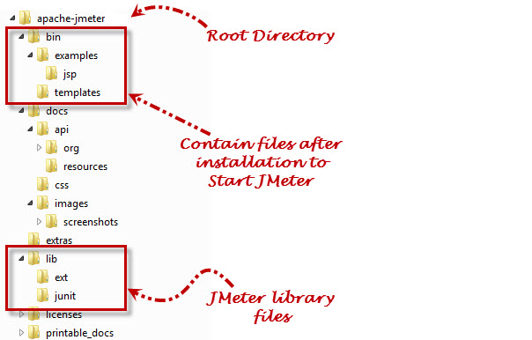

Files and directory which generate after installation of JMeter are given below,

/bin: Containsscript file which comes after installation of JMeter to start JMeter

/docs: Contains JMeter documentation files

/extras: ant connectedadditional files

/lib/: Contains Java library files of JMeter

/lib/ext: Contains protocols and core jar files for JMeter

/lib/junit: Contains JUnit library files of JMeter

To check, it got installed or not on Windows, go to the directory where did you unzip the .zip of .tgz file, open Apache-JMeter-2.11 folder, click on bin folder, and then click on JMeter.bat file will open v2.11 JMeter application. In UNIX machine type ./bin/JMeter on command prompt to open JMeter.

## Start JMeter in Three Different Modes

You can open JMeter using 3 modes –

* GUI Mode,
* Server Mode and
* Command Line Mode

### The GUI Mode: JMeter runs on client computer

In Windows – First, open Apache-JMeter-2.11 folder, click on bin folder, and then click on JMeter.bat file will open v2.11 JMeter application. Shown in figure below,

[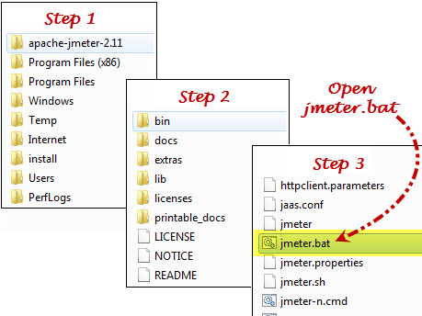](http://www.softwaretestingclass.com/wp-content/uploads/2014/02/jmeter-runs-on-client-computer1.jpg)

Once you click on JMeter.bat, it opens JMeter – 2.11, shown in figure below,

[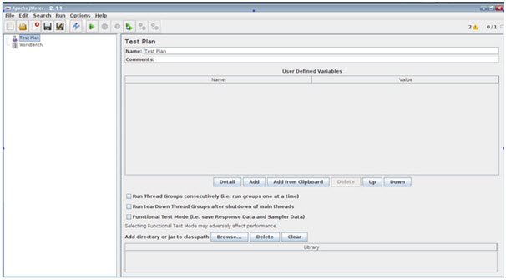](http://www.softwaretestingclass.com/wp-content/uploads/2014/02/jmeter-open-first-time.jpg)

### In Server Mode: JMeter runs on Server computer

It is basically a **client-server** model distributed testing mode. In this process, JMeter runs on server computer as a server component. To start JMeter in server mode, run the bat file: bin\**JMeter-server.bat, shown in the figure below,**

[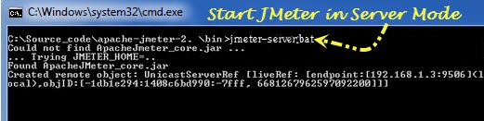](http://www.softwaretestingclass.com/wp-content/uploads/2014/02/jmeter-in-server-mode.jpg)

### In Command Line Mode

If we open JMeter in GUI mode, it takes more computer memory to open it.  If you don’t want your computer should consume more resources to run JMeter, open JMeter in command line mode.

Type this command in command line: “***JMeter -n -t testPlan.jmx – l log.jtl -H 127.0.0.1 -P 8000***”to open JMeter, shown in the figure below,

Where,

***JMeter–n***: Shows that JMeter will run on command line mode

***-t testPlan.jmx***: Name of file contains the Test plan

***– llog.jtl***: Shows the log files which contain the test result

***-H 127.0.0.1 -P 8000***: Proxy server host name and port

[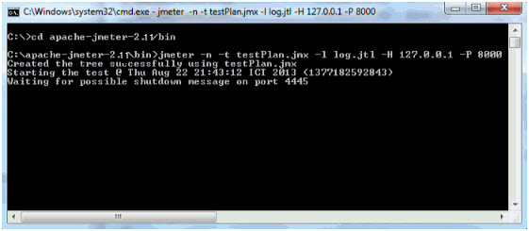](http://www.softwaretestingclass.com/wp-content/uploads/2014/02/jmeter-in-command-line-mode.jpg)